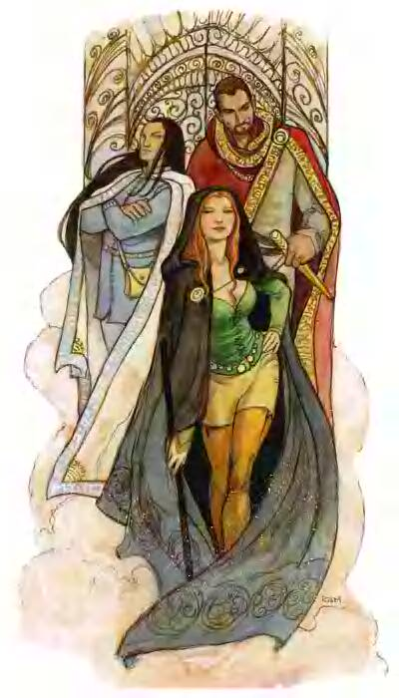
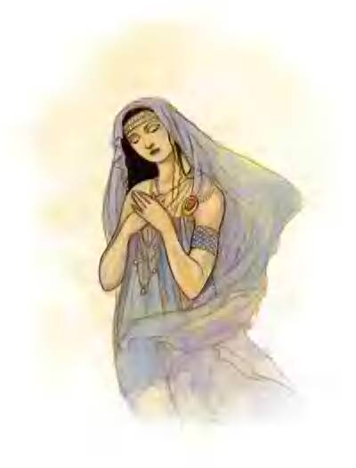
Fulfill your destiny! Come and get your fortune told by Clarina at Weer’s Elixirs. Weer’s specializes in tarot readings, love potions and astrology.
Flood Festival Itinerary Announced
In response to an uncommon season of rain, a young Sarcem Delasharn founded the first Flood Festival 32 years ago.
This Monday, all of Cauldron will wear masks to an all day party and at dusk clothing will be exchanged between sexes amidst general hilarity. Due to the weather, this is usually over clothing, though underclothing is not unheard of at Lady Rhiavadi’s House Party. Cauldron’s three great churches are sponsoring contests and events to celebrate the occasion. St. Cuthberts has contracted the Jingling Mordo Circus for entertainment. The carnival will set up at Vhalantru’s Park next to the Lakeside Pavilion. The Temple of Lordly Might is sponsoring a Tournament of Champions for knights to compete in and win the title of “Champion of Kord.” Wee Jas’ Cathedral produces the Many Splendor Fireworks Extravaganza each night of the weeklong festival. Pelor’s annual Free Feast Before Famine is cancelled this year due to a similar recent event that was sponsored by Tallia of the Rat Pack. Cauldron’s Merchant’s Guild reduces prices for all items by one-tenth. Just tell the proprietor “After the flood, all this will be cheaper.” On Waterday, the Hunt for the Crater Lake Monster is sponsored by Bluecrater Academy. 1 sp to enter. The Academy’s Amateur Talent Performances are scheduled daily on all the town squares. Lord Zachary Aslaxin holds the Demonskar Ball at the Cusp of the Sunrise (invitation only). In a completely new offspring event related to the festival, the Taskerhill manor in Kingfisher Hollow is celebrating an open day on the 2nd Monday of the festival. Reservations for overnight stays are recommended. Fireworks and food are provided by courtesy of Lord Ankhin Taskerhill.

Drink Down the Flood
Sign up for the most elaborate drinking contest in the Jungle. 64 participants start drinking beer at Minuta’s Board, 32 winners head to the Brass Trumpet to quaff ale, the Slippery Eel provides grog for the next 16, 8 go on to the Drunken Morkoth for rum, and the final four drink mead at the Tipped Tankard. Finally, two champions compete in a wine drinking contest at the Coy Nixie. All the festivities end when Lord Vhalantru challenges the last victor to a final bout at the Cusp of the Sunrise. 1 gold to enter.

Drakthar overcome by the Rat Pack
The goblin plague is over! Or so at least some news relayed by the city guard sound. The delivery of 43 goblin ears to the guard, 5 of those in particular lousy shape, together with the clearing of an underground complex beneath Orak's Bathhouse, which has now closed for renovations, are supposed to be the end to the constant annoyance of goblins creeping around in the city. Apparently a bugbear vampire had the buggers under his evil influence and was causing the havoc. The Rat Pack, however, prevailed in their quest to eradicate his hideout and restored peaceful nights for Cauldron. Together with the Church of St. Cuthbert they are successfully improving life quality in our beloved town.
Any further goblin sightings to be reported to Skylar Krevis.

This Week in Cauldron’s History
According to noted archaeologist Tygot Mispas, this Freeday marks the 50th anniversary of the Brigands and Slavers Campaign. Notorious Highwayman Black Bryan Battani plagued Grayhaunt’s trails for a dozen years. Led by Molly McTyre, the Band of the Black Veil ransacked Ramshorn Abbey. In response to these atrocious events, Lord Jaccobux Kincep tracked these criminals to their ultimate demise.

--- Post deadline news - Post deadline news ---
Town guard captain T. Skellerang: “Thanks to the constant vigilance of my troops, common crime (burglary, theft, break-ins) has gone down consi-derably compared to the previous month. Activity in that regard is at an all-year low. Heroes like the Stormblades and the Rat Pack are a benevolent addition to the forces of good keeping the town a standing stone against the untamed wild around it.”
by Vince (free columnist)
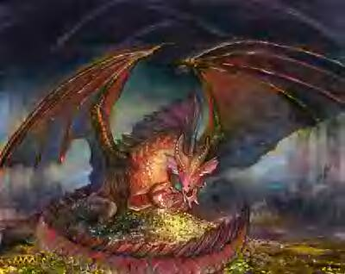
Hookface the dragon was spotted flying over the hills to the north.

