Evil Cult Defeated, Wands of Control Water Returned
An unholy union of criminals calling itself the Ebon Triad was discovered inhabiting ancient ruins of an ancient Kopru civilization beneath Cauldron. Triel Eldurast, wanted for the murder of several town guards 9 years ago, was captured and turned into custody. She allegedly had schemed to ransom the wands of control water once the city was sufficiently flooded. The “Rat Pack” managed to masterfully infiltrate the ancient stronghold and recover enough wands to allow town clerics to combat the flood. Jenya Urikas, High Priestess of St. Cuthbert, cautioned against the involvement of the Ebon Triad in this mischiefeous plot. “Their sole purpose is to unite three gods – Hextor, Vecna, and Erythnul – into one all-powerful deity. “
Greenleaf Shop
Magical curiosities
sold here -- step right in.
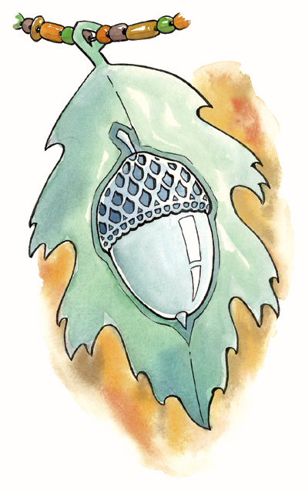
Make yourself unique -
get the fantastic silver oak amulet
for a mere 1280 gp !!!
It finds you oaks, fast !
Messages from the Clerics of Cauldron



Church of St. Cuthbert – Jenya Urikas - “Kill not the non-evil beasts of the land, and so not attack the fair people!”

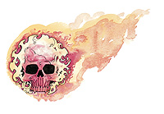

Cathedral of Wee Jas - Embril Aloustinia - “Strive not to wield the Great Force of Evil for its power will overcome thee!”



Temple of Lordly Might – Asfelkir Hranleurt -
“True valor is seen not in the force of arms, but in the force of will!”



Church of Pelor – Kristof Jurgensen – “Honor is like finely polished armour. Without constant care, it will soon tarnish!”
Rains Have Come !
Flood Festival Underway !
The annual Flood Festival is now in full swing, by proclamation of the Lord Mayor. “We have been preparing for the festival for weeks now, may Kord bless us and grant us strength and prosperity,” said Asfelkir Hranleurt, high priest of the temple of Kord who has coordinated many of the athletic events during the festival. “Though the rains shroud the rays of Pelor, his light and majesty shall shine on this joyous occasion,” said Kristof Jurgensen, acting high priest of the church of Pelor. Jenya Urikas from the temple of St. Cuthbert and Embril Aloustinai from the cathedral of Wee Jas were also at hand for the grand beginning of the festival.
Folks from far and wide have come to Cauldron to celebrate the rains. Both the Drink down the flood (won by Omar Tiskinsen) and the Crater Lake Monster Hunt (won by Ragnar Blackmane) were a smashing success and the streets are alive with visiting minstrels and local musicians vying for the attention of patrons. Local merchants are offering their customary price reductions for the duration of the festival. A joyous time is upon our fine city!

Rhiavadi expands silk patent

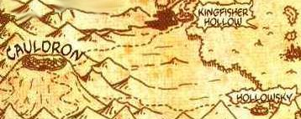
Since many decades House Rhiavadi owns the monopoly on all silk trading and production in Cauldron. Recently, Lady Thifirane stretched out her patent to Redgorge and Kingfisher Hollow. That leaves the half-elves of Hollowsky as the only competitors left. Elven Patriarch Sardis of the Hollow family responded calmly: “We have been in the silk business for many centuries. I don’t see any reason, why we should be concerned.”
Feared bugbear defeated

Farmers around Cauldron were relieved when a bugbear bandit leader terrorizing our territory was eliminated. The head of Hilgor Rimtooth was brought into town two days ago by the Stormblades. Todd Vanderboren carried the head which was pinned on a stake through the North gate and delivered it to sergeant Krewis.
Zachary tracked the bandits to their lair, a miserable stinking cave, according to Annah: “First thing I‘ll do is taking a long hot bath!”
The bounty due was paid, but more than half of it went straight to the “Flood festival fund”, a rally to help the poor people living near the lakeshore to enforce their houses against floods like the one about to hit Cauldron again.

Demonskar ball preparations commence

Lord Zachary Aslaxin I and Lady Margaret Aslaxin are back in town at the Coy Nixie preparing their guest list for the Demonskar Ball, celebrating the battle between our city’s glorious founder Surabar Spellmason and the demon Nabthatoron. This invitation-only event is for many the highlight of the Flood Festival and is held on the last night of the festival. With a polite smile, Lady Aslaxin refused to disclose who would be receiving the special ‘Nabthatoron’ invitation this year. Several special invites have been circulated between the churches and the public is poised to find out who will be this year's champions of the ball. Bluecrater academy is actively looking for additional dance instructors.

