Scroll & Feather

Cauldron Saved From the Flood
Prior to the Flood Season, Sarcem Delasharn went to Sasserine to buy Wands of Control Water to protect Cauldron against the flood.
The new High Priestess of St. Cuthbert, Jenya Urikas, received a sending spell from Sarcem while he was at the Lucky Monkey. Somehow she managed to get the Hand of Destiny to the Lucky Monkey in a matter of hours, instead of days.
There they managed to stop the Alleybashers, a group of thieves from Sasserine, which had attacked the inn. But to they were too late. Sarcem was dead and the wands gone.
The Hand of Destiny returned to Cauldron and discovered that Triel Eldurast was behind the attack, and that she had a hideout beneath Cauldron. With a swift and decisive attack, the group killed the rest of the alleybashers and their leader, Triel. The group returned victoriously with the eight wands Sarcem had bought in Sasserine.

Durgeddon beats Vhalantru
The almost 300-year-old dwarf won the drinking contest held during the Flood festival. It lasted more than ten ours before Lord Vhalantru lost consciousness. Durgeddon the Black held a short victory speech before

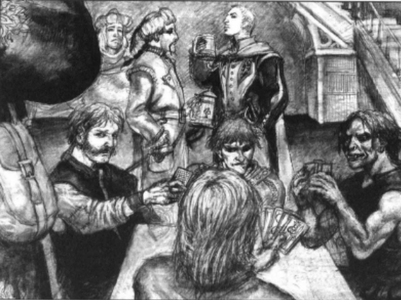
The Drunken Morkoth Inn during the competition

he too lost consciousness: “It is really strange that a half-elf can keep his liquor that well. But nobody can beat a dwarf who hasn’t had an ale in a hundred years. Gimme another ale!“

The Lantern-man is Caught
Victor Langston and Skylar Krewis managed to catch the Lanternman who has killed and mutilated over nine people during the last weeks. His name is still unknown, but rumours tell of a fisherman who worked in the Crater Lake. Lord Mayor Navalant, Lord Taskerhill and Lord Vhalantru will judge him this Moonday. In the meantime, he will be locked up in the Asylum.
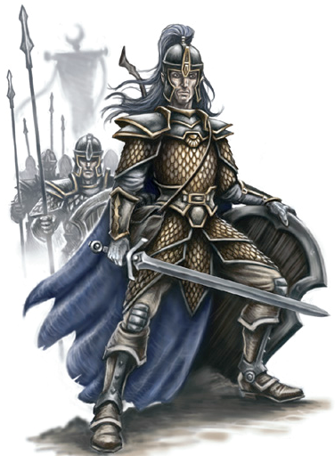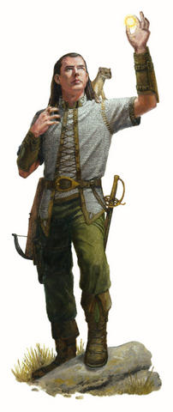

Victor Langston and Skylar Krewis

Zombies Attack Redgorge!
Hordes of zombies have attacked Redgorge. Only six people were killed, due to Dragor Tulor and Elanna Ultans divine powers. They used the light of Pelor to chase away the evil, and saved several hundred people from certain death. An unknown adventure group opened an ancient crypt, and removed a magical item, which trapped a great evil. Dragor Tulor, a member of The Hand of Destiny, did what was necessary to put the ancient evil to rest.

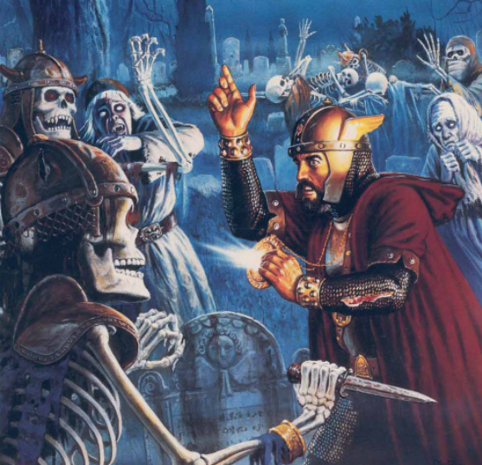
Illustration of what happened in Redgorge

Weapons Allowed in Cauldron
After a long debate in the City Council, Durgeddon the Black convinced the Council that the weapon laws in place were illegal, and that for the good of everyone in Cauldron, they must be repealed. Lord Vhalantru was strongly against what Durgeddon wanted, but both Lord Taskerhill and Lord Mayor Navalant voted for the law to be repealed.
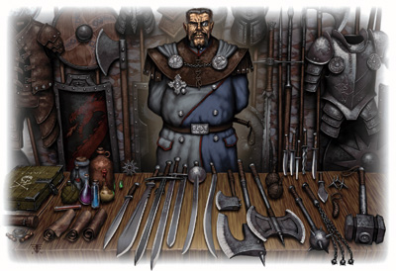
The Blacksmiths celebrate

The People of Cauldron ran toward the nearest weapon smith to buy what they could get their hands on. The next day, all was sold.

Elad Edals Caught,
Sentence: Innocent
Elad Edals was caught by Victor Langston and Skylar Krewis after he returned to Cauldron to kill Marl Kollinar, the leader of the Merchant Guild. He was wanted for the murder of Gillian Gildeket that happened four years ago when he returned to the city. Strange as it sounds, Langston, the man who helped catch the wanted assassin, took the role as defender when Elad Edals was judged. With new proof, that proved Elad Edals innocent, he convinced the city council to let the man be free.
Marl Kollinar was arrested in his home the same day. After a quick trial, he was sentenced to death for the murder of Gillian Gildeket, the prior leader of the Merchant Guild. Even though he did not commit it, he was the one who ordered the assassination.

Heard on the Street
A group called the Striders of Fharlanghn have defeated a big bandit army west of Cauldron.

A thieves’ guild called The Watchers has been destroyed by another guild. Captain Skellerang has promised that the city watch will put an end to this disturbance.

A female elf stole a bag full of gamblers from Marl Kollinar the night before his arrest. The thief is still at large.

The Company of the Spider has disappeared in the mountains north of Cauldron.

Kingfisher’s Hollow has found the lost treasure that was stolen 40 years ago. Who did it, is still unknown.

Bandits have attacked and killed another of Maavu Imports’ caravans in the mountains between Cauldron and Sasserine.

Nedylen Illistyn won the Campionship of Kord.

More wererats have been seen in Cauldron lately. A mason was attacked when he was on the way home after doing maintenance at the Cathedral of Wee Jas.

During the Hunt for the Monster in the Crater Lake, four adventure parties met their doom. The only one, who met the monster and managed to get away, was “Bisquaynes Absolutely Final Army And This Time I Really Mean It.” Only one survived.

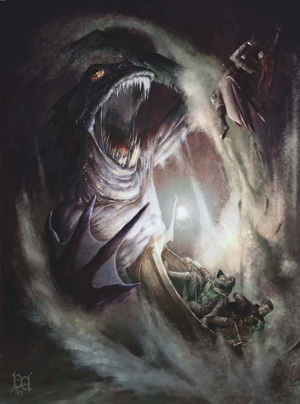
Hunt for the Crater Lake Monster

